**AVL Tree**

AVL tree is a self-balancing binary search tree in which each node maintains extra information called a balance factor whose value is either -1, 0 or +1.

AVL tree got its name after its inventor Georgy Adelson-Velsky and Landis.

**Balance Factor**

Balance factor of a node in an AVL tree is the difference between the height of the left subtree and that of the right subtree of that node.

Balance Factor = (Height of Left Subtree - Height of Right Subtree) or (Height of Right Subtree - Height of Left Subtree)

The self balancing property of an avl tree is maintained by the balance factor. The value of balance factor should always be -1, 0 or +1.

An example of a balanced avl tree is:

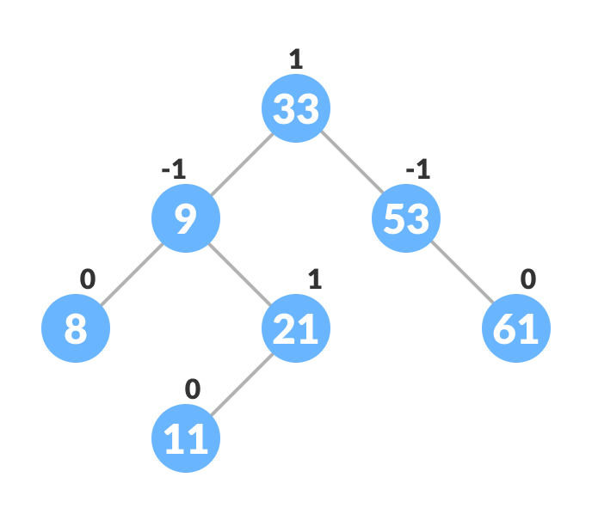Avl tree

**Operations on an AVL tree**

Various operations that can be performed on an AVL tree are:

**Rotating the subtrees in an AVL Tree**

In rotation operation, the positions of the nodes of a subtree are interchanged.

There are two types of rotations:

**Left Rotate**

In left-rotation, the arrangement of the nodes on the right is transformed into the arrangements on the left node.

Algorithm

1. Let the initial tree be: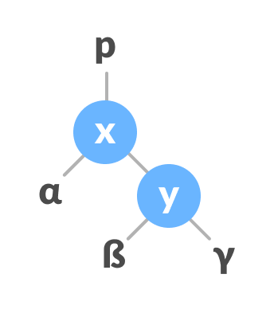Left rotate
2. If y has a left subtree, assign x as the parent of the left subtree of y.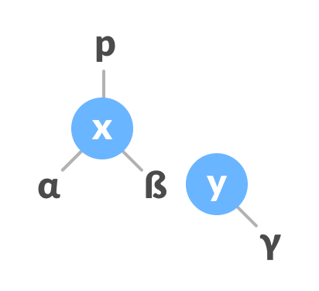Assign x as the parent of the left subtree of y
3. If the parent of x is NULL, make y as the root of the tree.
4. Else if x is the left child of p, make y as the left child of p.
5. Else assign y as the right child of p.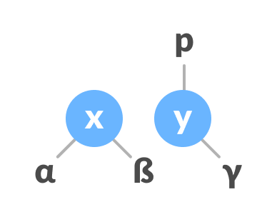Change the parent of x to that of y
6. Make y as the parent of x.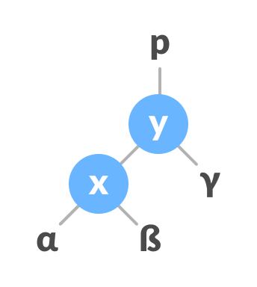Assign y as the parent of x.

**Right Rotate**

In left-rotation, the arrangement of the nodes on the left is transformed into the arrangements on the right node.

1. Let the initial tree be: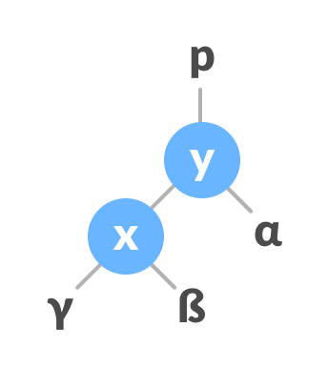Initial tree
2. If x has a right subtree, assign y as the parent of the right subtree of x.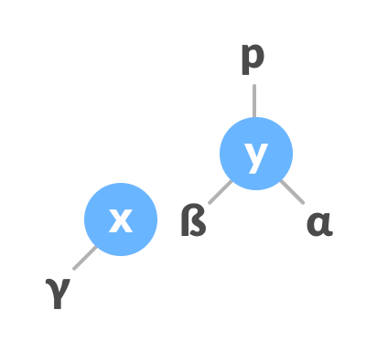Assign y as the parent of the right subtree of x
3. If the parent of y is NULL, make x as the root of the tree.
4. Else if y is the right child of its parent p, make x as the right child of p.
5. Else assign x as the left child of p.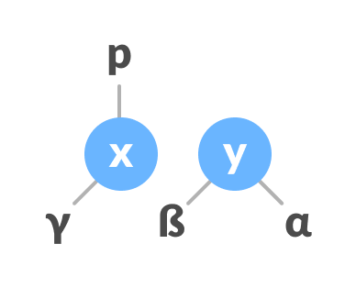Assign the parent of y as the parent of x.
6. Make x as the parent of y.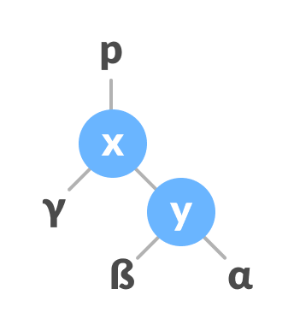Assign x as the parent of y

**Left-Right and Right-Left Rotate**

In left-right rotation, the arrangements are first shifted to the left and then to the right.

1. Do left rotation on x-y.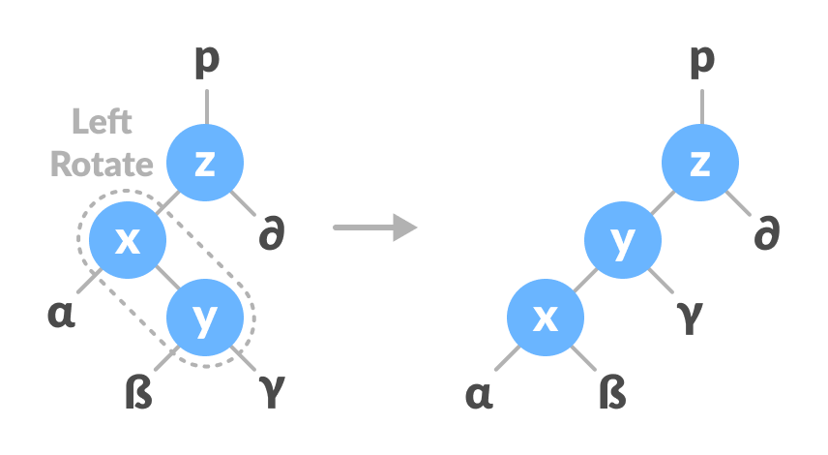Left rotate x-y
2. Do right rotation on y-z.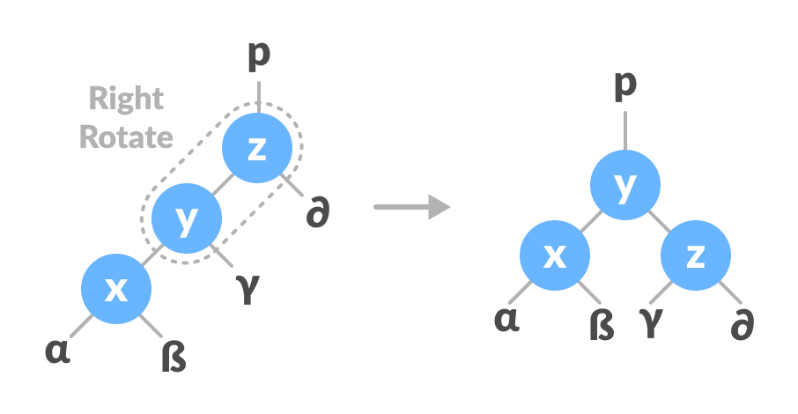Right rotate z-y

In right-left rotation, the arrangements are first shifted to the right and then to the left.

1. Do right rotation on x-y.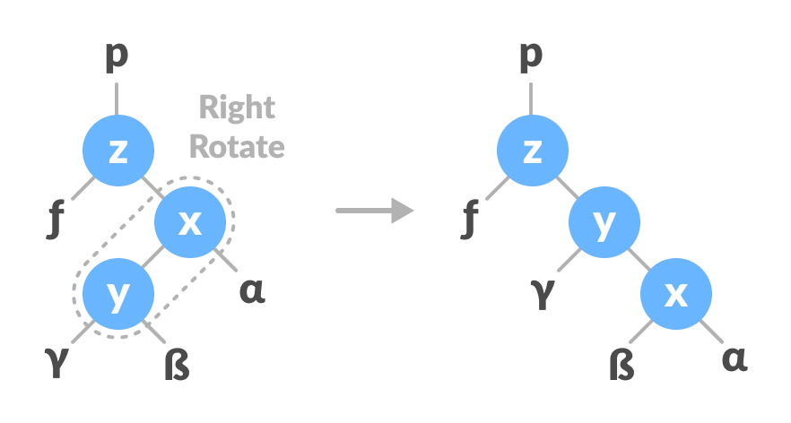Right rotate x-y
2. Do left rotation on z-y.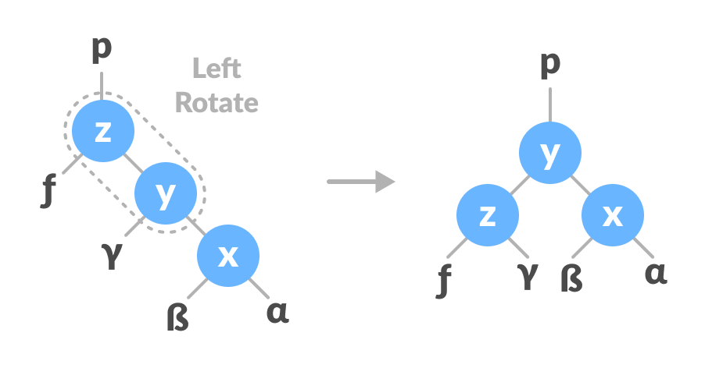Left rotate z-y

**Algorithm to insert a newNode**

A newNode is always inserted as a leaf node with balance factor equal to 0.

1. Let the initial tree be: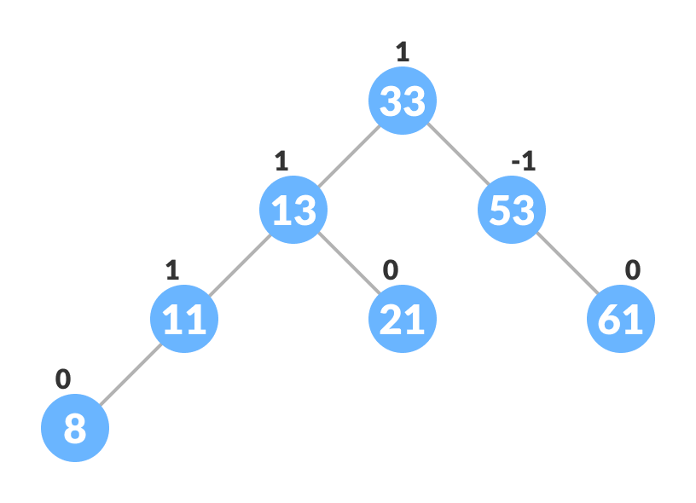Initial tree for insertion  
   Let the node to be inserted be:New node
2. Go to the appropriate leaf node to insert a newNode using the following recursive steps. Compare newKey with rootKey of the current tree.
   1. If newKey < rootKey, call insertion algorithm on the left subtree of the current node until the leaf node is reached.
   2. Else if newKey > rootKey, call insertion algorithm on the right subtree of current node until the leaf node is reached.
   3. Else, return leafNode.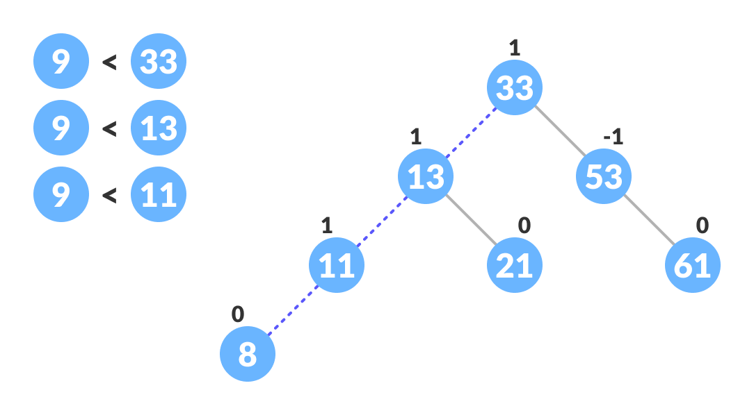Finding the location to insert newNode
3. Compare leafKey obtained from the above steps with newKey:
   1. If newKey < leafKey, make newNode as the leftChild of leafNode.
   2. Else, make newNode as rightChild of leafNode.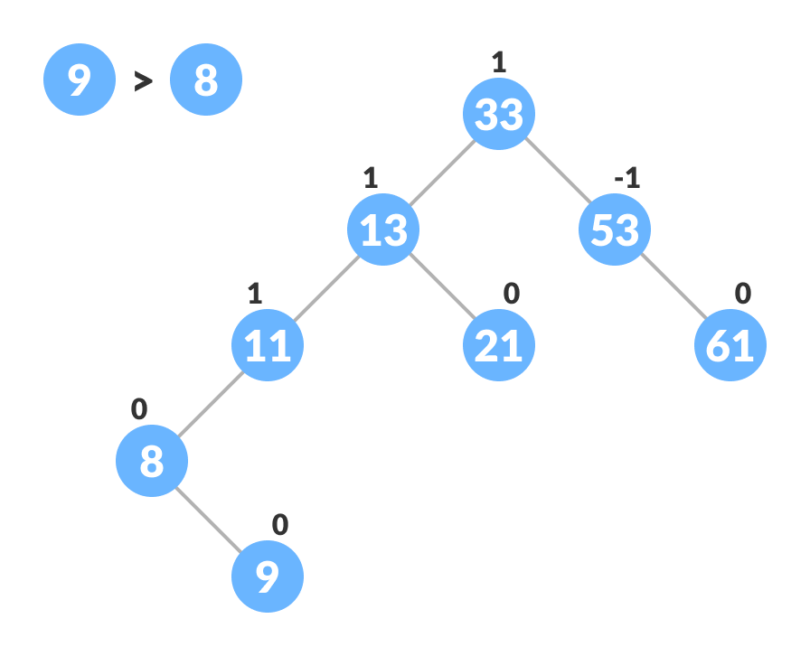Inserting the new node
4. Update balanceFactor of the nodes.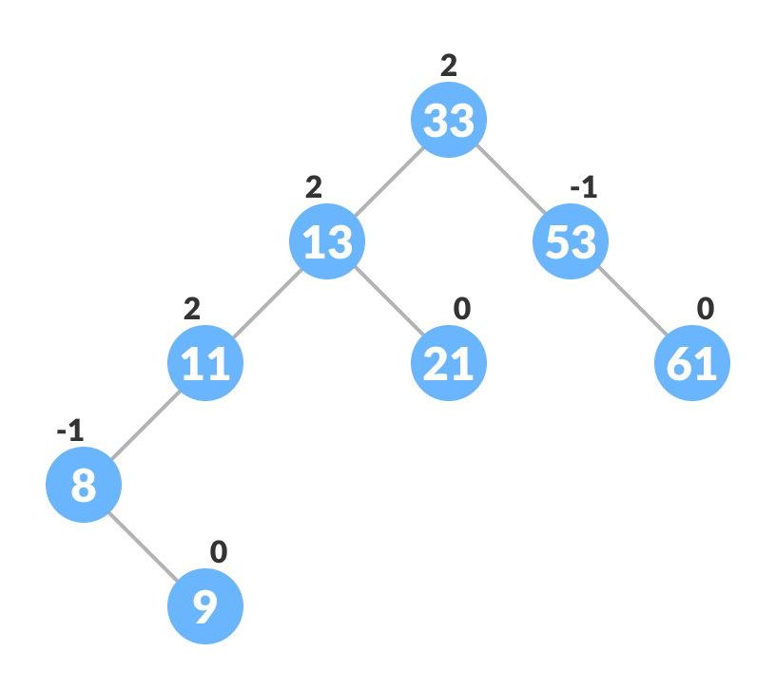Updating the balance factor after insertion
5. If the nodes are unbalanced, then rebalance the node.
   1. If balanceFactor > 1, it means the height of the left subtree is greater than that of the right subtree. So, do a right rotation or left-right rotation
      1. If newNodeKey < leftChildKey do right rotation.
      2. Else, do left-right rotation.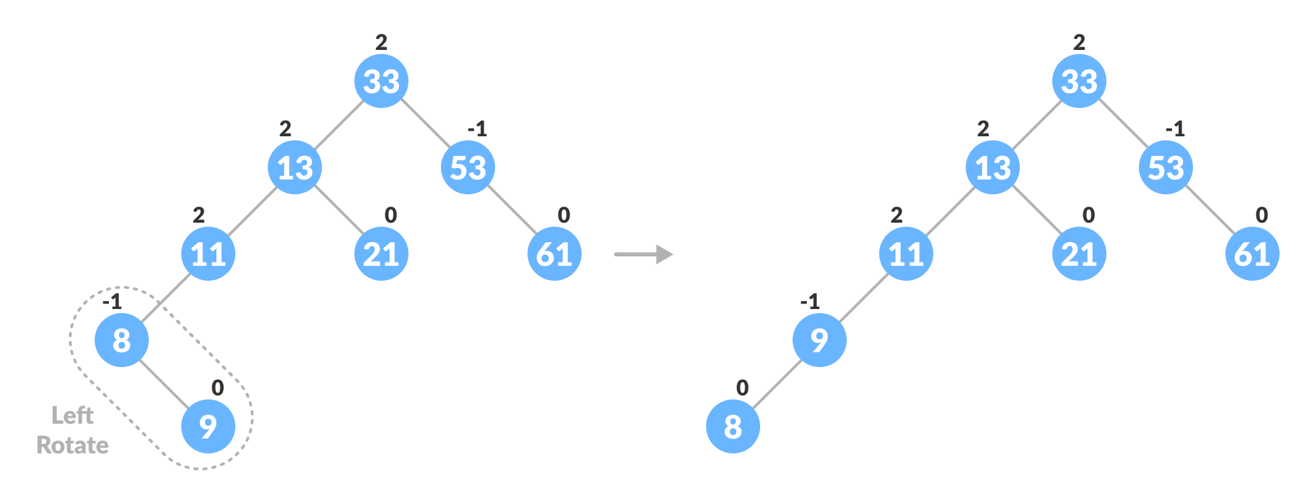Balancing the tree with rotation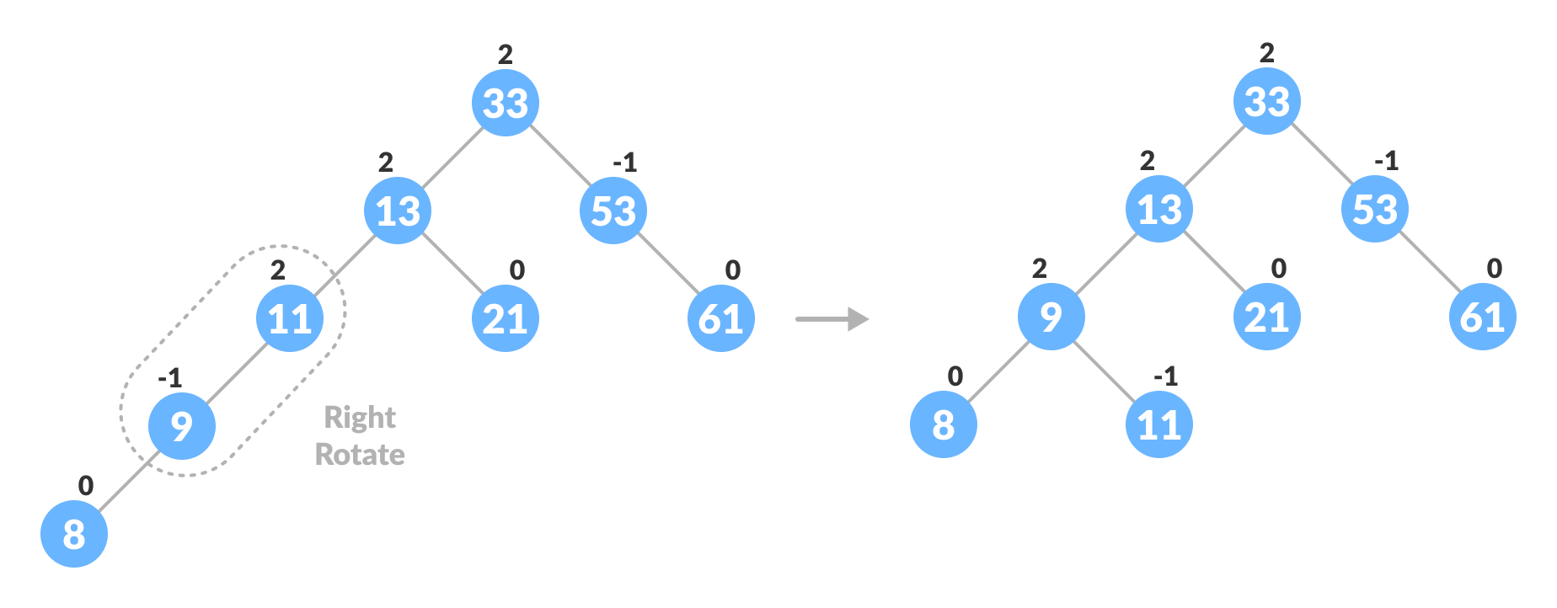Balancing the tree with rotation
   2. If balanceFactor < -1, it means the height of the right subtree is greater than that of the left subtree. So, do right rotation or right-left rotation
      1. If newNodeKey > rightChildKey do left rotation.
      2. Else, do right-left rotation
6. The final tree is: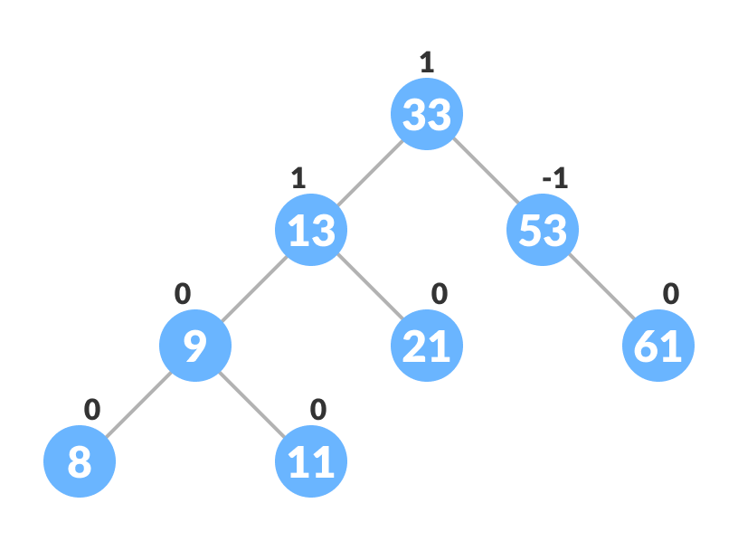Final balanced tree

**Algorithm to Delete a node**

A node is always deleted as a leaf node. After deleting a node, the balance factors of the nodes get changed. In order to rebalance the balance factor, suitable rotations are performed.

1. Locate nodeToBeDeleted (recursion is used to find nodeToBeDeleted in the code used below).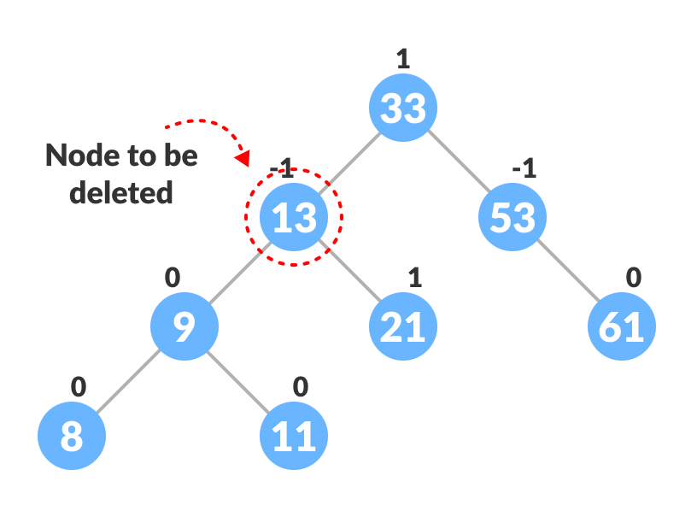Locating the node to be deleted
2. There are three cases for deleting a node:
   1. If nodeToBeDeleted is the leaf node (ie. does not have any child), then remove nodeToBeDeleted.
   2. If nodeToBeDeleted has one child, then substitute the contents of nodeToBeDeleted with that of the child. Remove the child.
   3. If nodeToBeDeleted has two children, find the inorder successor w of nodeToBeDeleted (ie. node with a minimum value of key in the right subtree).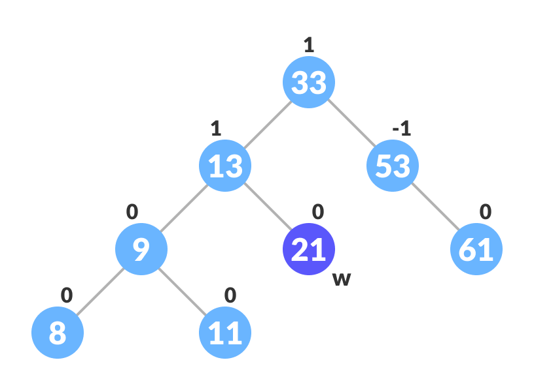Finding the successor
      1. Substitute the contents of nodeToBeDeleted with that of w.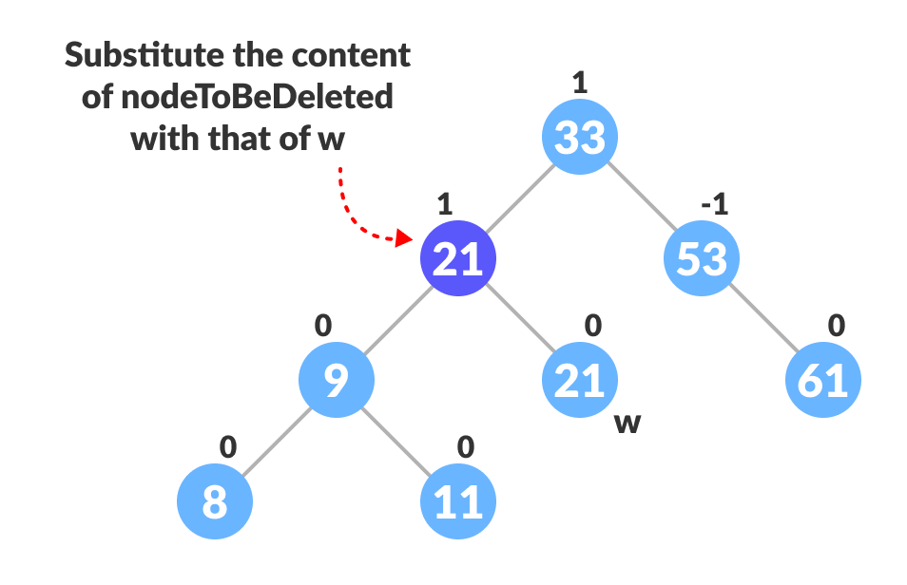Substitute the node to be deleted
      2. Remove the leaf node w.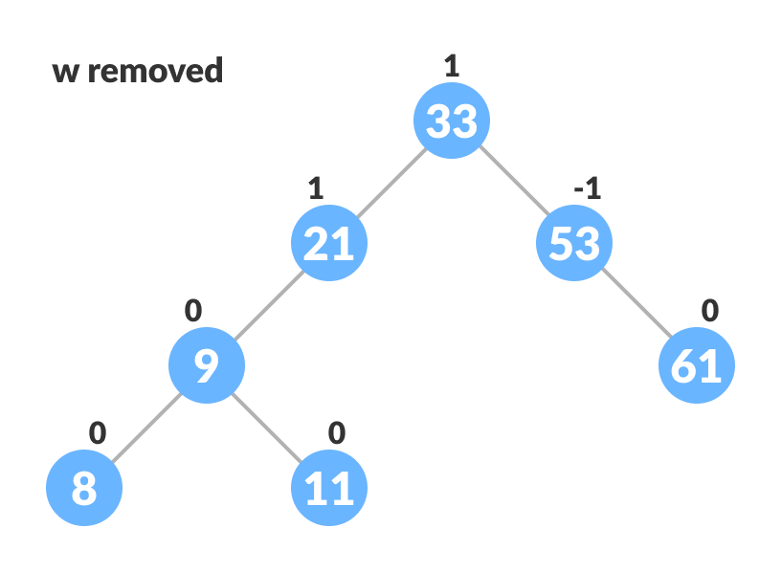Remove w
3. Update balanceFactor of the nodes.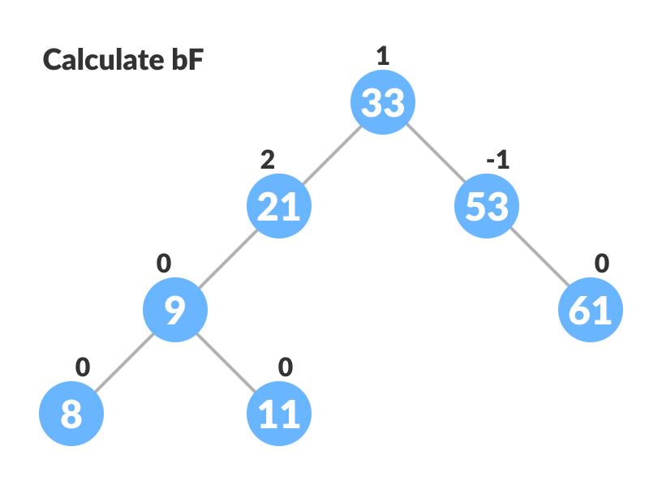Update bf
4. Rebalance the tree if the balance factor of any of the nodes is not equal to -1, 0 or 1.
   1. If balanceFactor of currentNode > 1,
      1. If balanceFactor of leftChild >= 0, do right rotation.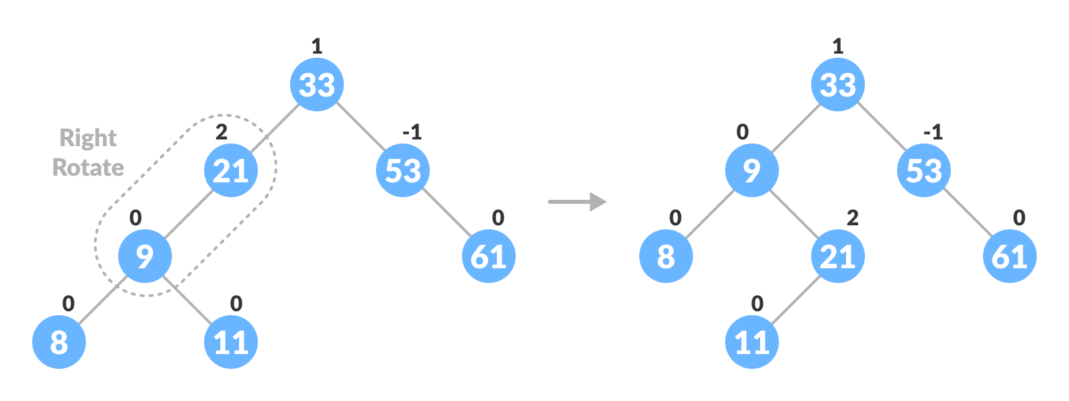Right-rotate for balancing the tree
      2. Else do left-right rotation.
   2. If balanceFactor of currentNode < -1,
      1. If balanceFactor of rightChild <= 0, do left rotation.
      2. Else do right-left rotation.
5. The final tree is:Avl tree final

**Java**

[Java](https://www.programiz.com/dsa/avl-tree#java-code)

// AVL tree implementation in Java

// Create node

class Node {

int item, height;

Node left, right;

Node(int d) {

item = d;

height = 1;

}

}

// Tree class

class AVLTree {

Node root;

int height(Node N) {

if (N == null)

return 0;

return N.height;

}

int max(int a, int b) {

return (a > b) ? a : b;

}

Node rightRotate(Node y) {

Node x = y.left;

Node T2 = x.right;

x.right = y;

y.left = T2;

y.height = max(height(y.left), height(y.right)) + 1;

x.height = max(height(x.left), height(x.right)) + 1;

return x;

}

Node leftRotate(Node x) {

Node y = x.right;

Node T2 = y.left;

y.left = x;

x.right = T2;

x.height = max(height(x.left), height(x.right)) + 1;

y.height = max(height(y.left), height(y.right)) + 1;

return y;

}

// Get balance factor of a node

int getBalanceFactor(Node N) {

if (N == null)

return 0;

return height(N.left) - height(N.right);

}

// Insert a node

Node insertNode(Node node, int item) {

// Find the position and insert the node

if (node == null)

return (new Node(item));

if (item < node.item)

node.left = insertNode(node.left, item);

else if (item > node.item)

node.right = insertNode(node.right, item);

else

return node;

// Update the balance factor of each node

// And, balance the tree

node.height = 1 + max(height(node.left), height(node.right));

int balanceFactor = getBalanceFactor(node);

if (balanceFactor > 1) {

if (item < node.left.item) {

return rightRotate(node);

} else if (item > node.left.item) {

node.left = leftRotate(node.left);

return rightRotate(node);

}

}

if (balanceFactor < -1) {

if (item > node.right.item) {

return leftRotate(node);

} else if (item < node.right.item) {

node.right = rightRotate(node.right);

return leftRotate(node);

}

}

return node;

}

Node nodeWithMimumValue(Node node) {

Node current = node;

while (current.left != null)

current = current.left;

return current;

}

// Delete a node

Node deleteNode(Node root, int item) {

// Find the node to be deleted and remove it

if (root == null)

return root;

if (item < root.item)

root.left = deleteNode(root.left, item);

else if (item > root.item)

root.right = deleteNode(root.right, item);

else {

if ((root.left == null) || (root.right == null)) {

Node temp = null;

if (temp == root.left)

temp = root.right;

else

temp = root.left;

if (temp == null) {

temp = root;

root = null;

} else

root = temp;

} else {

Node temp = nodeWithMimumValue(root.right);

root.item = temp.item;

root.right = deleteNode(root.right, temp.item);

}

}

if (root == null)

return root;

// Update the balance factor of each node and balance the tree

root.height = max(height(root.left), height(root.right)) + 1;

int balanceFactor = getBalanceFactor(root);

if (balanceFactor > 1) {

if (getBalanceFactor(root.left) >= 0) {

return rightRotate(root);

} else {

root.left = leftRotate(root.left);

return rightRotate(root);

}

}

if (balanceFactor < -1) {

if (getBalanceFactor(root.right) <= 0) {

return leftRotate(root);

} else {

root.right = rightRotate(root.right);

return leftRotate(root);

}

}

return root;

}

void preOrder(Node node) {

if (node != null) {

System.out.print(node.item + " ");

preOrder(node.left);

preOrder(node.right);

}

}

// Print the tree

private void printTree(Node currPtr, String indent, boolean last) {

if (currPtr != null) {

System.out.print(indent);

if (last) {

System.out.print("R----");

indent += " ";

} else {

System.out.print("L----");

indent += "| ";

}

System.out.println(currPtr.item);

printTree(currPtr.left, indent, false);

printTree(currPtr.right, indent, true);

}

}

// Driver code

public static void main(String[] args) {

AVLTree tree = new AVLTree();

tree.root = tree.insertNode(tree.root, 33);

tree.root = tree.insertNode(tree.root, 13);

tree.root = tree.insertNode(tree.root, 53);

tree.root = tree.insertNode(tree.root, 9);

tree.root = tree.insertNode(tree.root, 21);

tree.root = tree.insertNode(tree.root, 61);

tree.root = tree.insertNode(tree.root, 8);

tree.root = tree.insertNode(tree.root, 11);

tree.printTree(tree.root, "", true);

tree.root = tree.deleteNode(tree.root, 13);

System.out.println("After Deletion: ");

tree.printTree(tree.root, "", true);

}

}

**Complexities of Different Operations on an AVL Tree**

|  |  |  |
| --- | --- | --- |
| **Insertion** | **Deletion** | **Search** |
| O(log n) | O(log n) | O(log n) |

**AVL Tree Applications**

* For indexing large records in databases
* For searching in large databases